**PART 2**

**ANALYSIS AND DESIGN OF THE “AI-POWERED AIR QUALITY MONITORING SYSTEM”**

**2.1. SURVEY THE SITUATION:**

**2.1.1. In the world:**

**A. Widespread Pollution:** According to the 2024 World Air Quality Report by IQAir, only 17% of global cities met the World Health Organization's (WHO) air pollution guideline for PM2.5 levels.

**B. Most Polluted Countries:** Chad and Bangladesh topped the list of the most polluted countries, with PM2.5 levels exceeding WHO guidelines by up to 15 times.

**C. Health Impact:** The State of Global Air 2024 report indicates that air pollution was responsible for approximately 8.1 million deaths globally in 2021, making it the second leading risk factor for death worldwide. 

* **Countries Meeting WHO Standards:** Only seven countries met the WHO's annual average PM2.5 guideline of 5 µg/m³ in 2024: Australia, Bahamas, Barbados, Estonia, Grenada, Iceland, and New Zealand. ​
* **Cities with Clean Air:** Cities like Stockholm, Tokyo, and Canberra have been recognized for maintaining low air pollution levels, attributed to effective emission regulations, clean energy transitions, and investments in public transportation.



**2.1.2. In Vietnam:**

**A. Global Ranking**: Vietnam was ranked **22nd** in global air pollution levels in 2023, making it the **second most polluted country in Southeast Asia**, just after Indonesia.

**B. Hanoi's Air Quality**: The capital city, **Hanoi**, was identified as the **8th most polluted city worldwide** in 2023. In March of that year, residents experienced only one day with "moderate" air quality and none with "good" air quality.

**C. PM2.5 Levels**: The annual average **PM2.5 concentration** in Vietnam reached **29.6 µg/m³** in 2023, nearly **6 times higher** than the World Health Organization's recommended limit of 5 µg/m³.

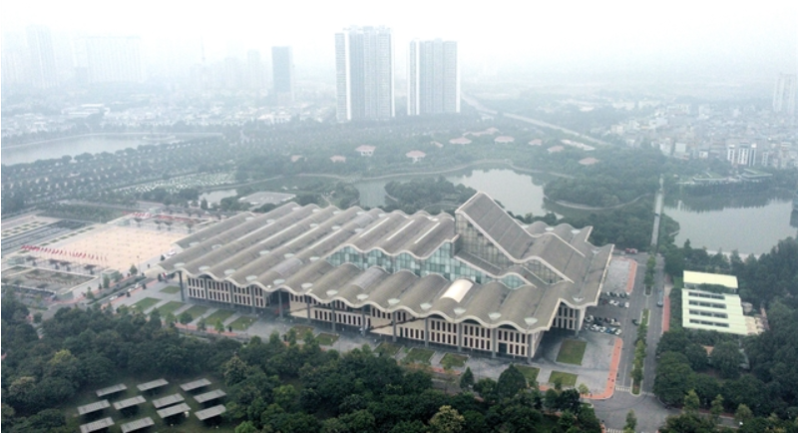

* **Monitoring Expansion**: Vietnam plans to construct **98 continuous automatic air quality monitoring stations** by 2030 to enhance data collection and public awareness.
* **Hanoi's Targets**: Hanoi aims to ensure that up to **80% of the days** in a year have air quality levels rated as good or moderate, based on data from standard national and city monitoring stations.

**2.2. SOME WEBSITES TO VIEW AIR QUALITY INDEX (AQI):**

* **IQAir:**

Link: <https://www.iqair.com/vi/>

Advantages: The web content is clear, specific and shows each air quality index. It is possible to specify the location to view air quality data.

Disadvantages: The web content so many detail, that make it become lag and vulnerable to some weak laptop.

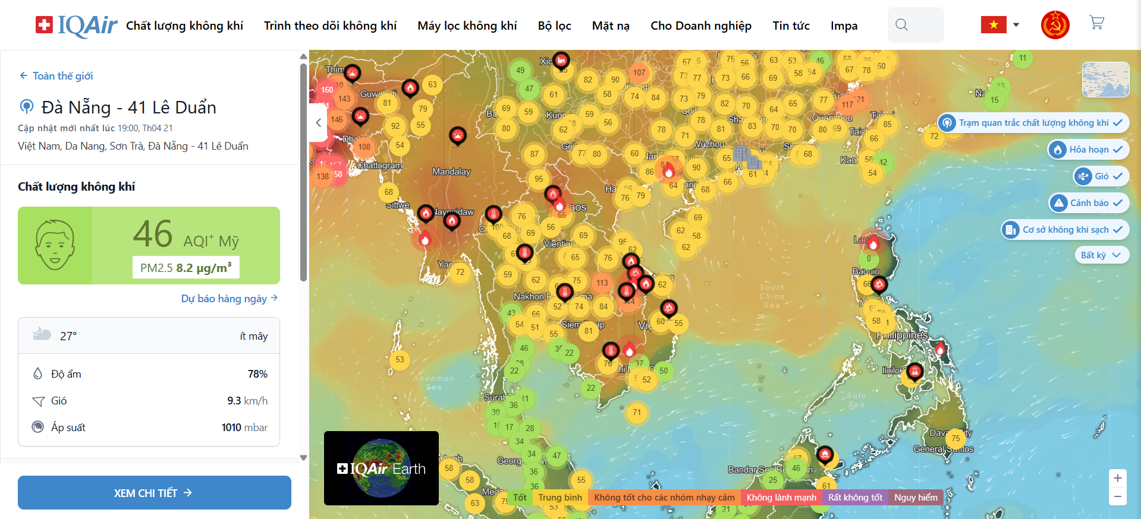

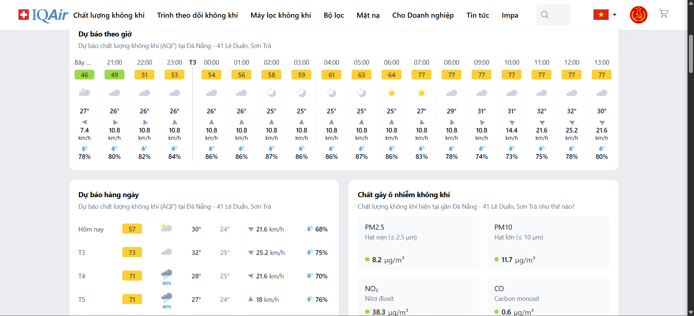

* **World's Air Pollution: Real-time Air Quality Index**

Link: <https://waqi.info/#/c/4.119/8.212/2.2z>

Advantages: Good content, with indicators displayed on the map. Complete and reputable data.

Disadvantages: The web content so many detail, that make it become lag and vulnerable to some weak laptop.

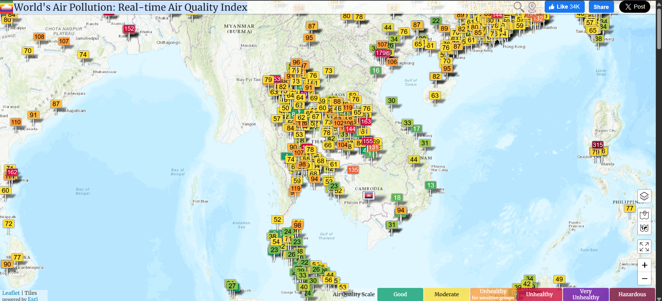

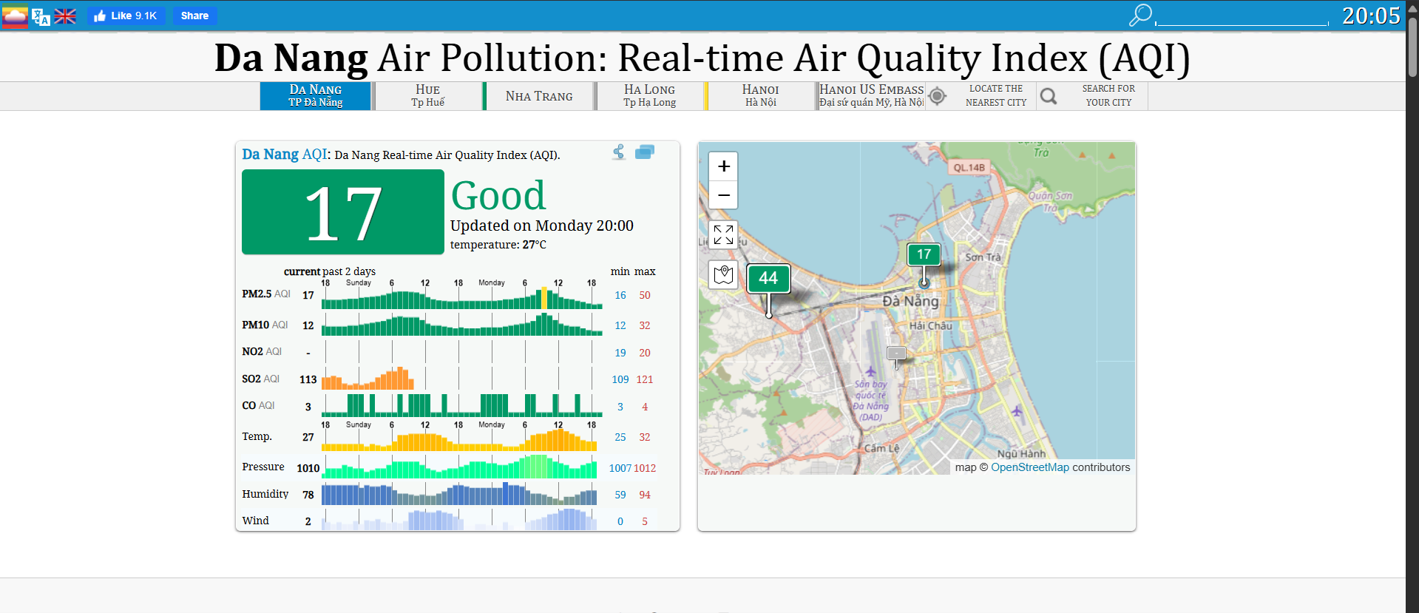

**2.3. OBJECTS INTERACTING WITH THE SYSTEM:**

The system has actors: Guest, User, Admin, Sensor.

The roles of the actors are shown in table… as follow:

|  |  |  |
| --- | --- | --- |
| NUM | Actor | Describe |
| 1 | Guest | Guest who are not logged in have access only to some general information about air quality and environmental indicators. |
| 2 | User | Registered users can personalize data displays, receive alerts, and track air quality history and forecasts. |
| 3 | Admin | System administrator, responsible for managing sensor data, setting alarm thresholds, processing reports, and approving system-related content. |
| 4 | Sensor | The device collects environmental data (pollution index, temperature, humidity, etc.) and sends the data continuously to the system. |

**2.4. USECASE DIAGRAM:**

**2.4.1. Main usecase:**

* Main usecase:

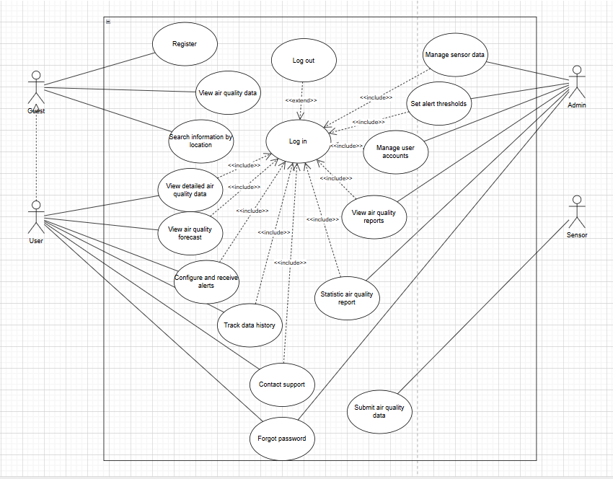

* Guest’s main usecase:

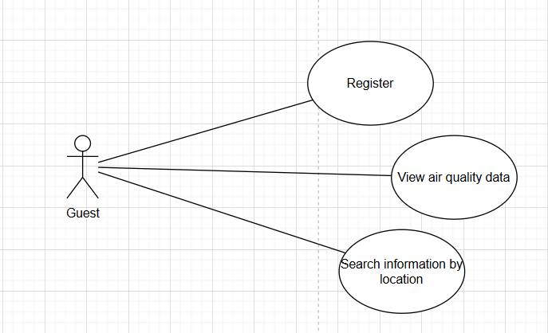

* User’s main usecase:

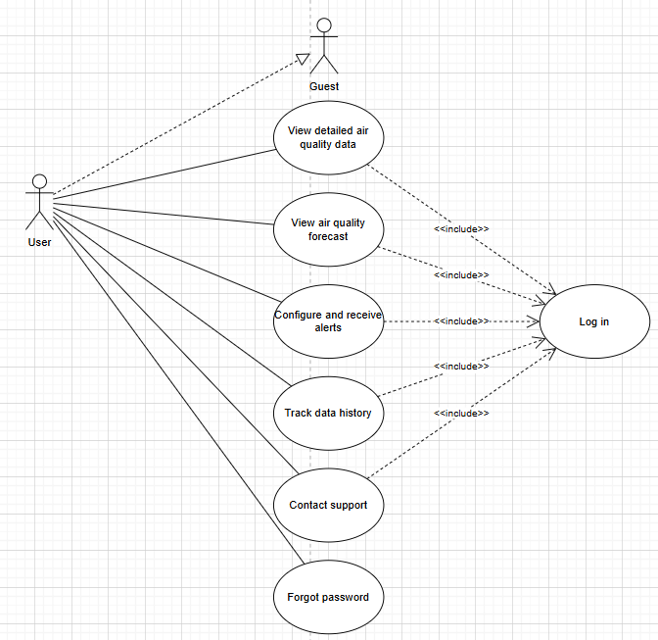

* Admin’s main usecase:

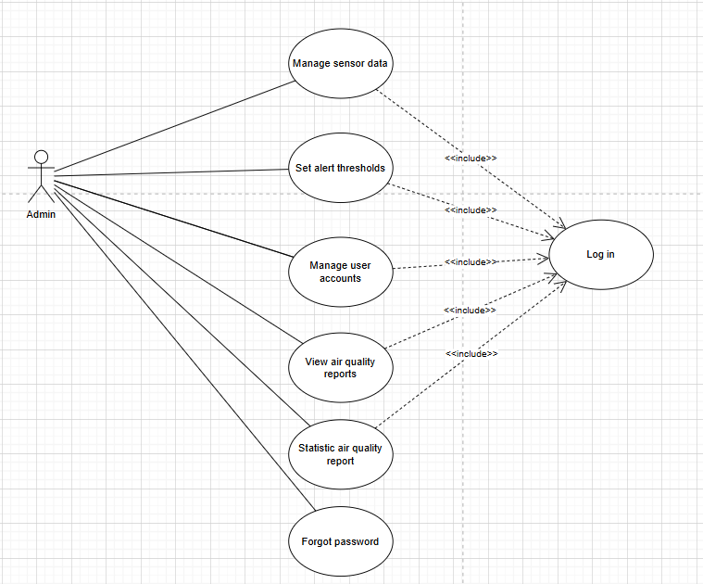

* Sensor’s main usecase:

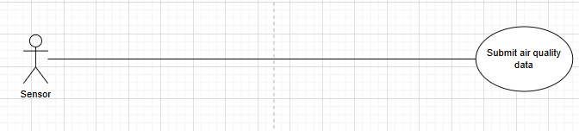

**2.4.2. Detail usecases:**

**2.4.2.1. (Guest) Register usecase:**

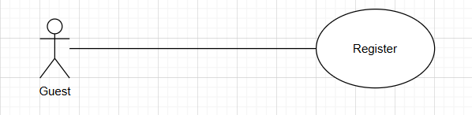

**Purpose: Guests** register an account to access additional features.

**Actors and General Description:**

* **Actors:** Guest.
* **General Description:** Describes the process of a user registering a new account.

**Main Event Flow:**

|  |  |
| --- | --- |
| Actor's Action | System Response |
| 1. User selects the "**Register Account**" option.  -  3. Enters registration information.  4. Submits the registration information.  -  - | -  2. Displays the account registration form.  -  -  5. Validates the information. If valid, shows success message; otherwise, shows error.  6. Ends the use case. |

**Alternative Flow:** If the registration information is invalid, the system prompts the guest to re-enter it.

**Specific Requirements:** Phone number and email must be entered in the correct format.

**Preconditions:** None.

**Postconditions:** None.

**2.4.2.2. (Guest) View air quality data usecase:**

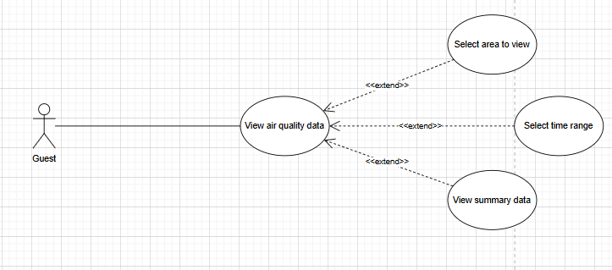

**Purpose:** Allow **guests** to view air quality data posts.

**Actors and General Description:**

* **Actors:** Guest.
* **General Description:** Describes the process by which a guest views the content of a data post.

**Main Event Flow:**

|  |  |
| --- | --- |
| Actor's Action | System Response |
| 1. Guest selects a data post.  -  - | -  2. Displays the data post content form.  3. Ends the use case. |

**Alternative Flow:** None.

**Specific Requirements:** None.

**Preconditions:** None.

**Postconditions:** None.

**2.4.2.3. (Guest) Search information by location usecase:**

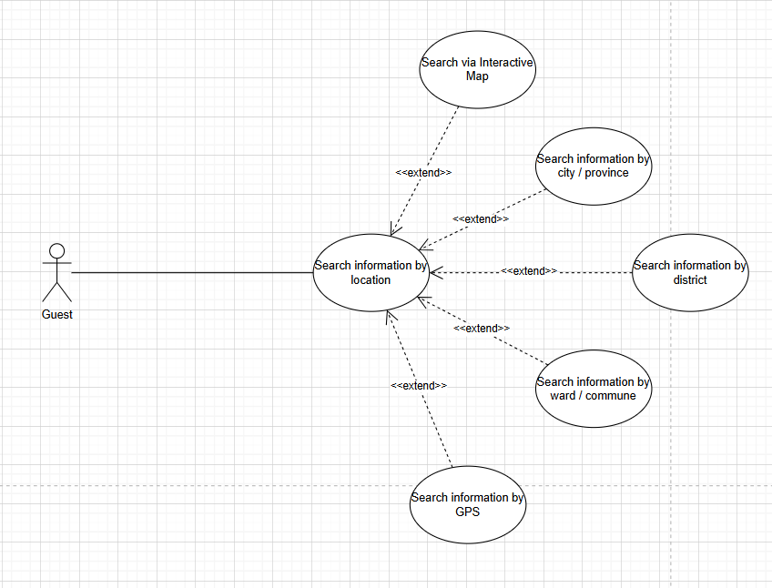

**Purpose: Guests** allow to search the data article.

**Actors and General Description:**

* **Actors:** Guest.
* **General Description:** Describes the process of a guest searching information from the relevant locations.

**Main Event Flow:**

|  |  |
| --- | --- |
| Actor's Action | System Response |
| 1. Enter search content into the search box.  2. Submit the entered information to the system  - | -  -  3. Display the list of found location.  4. End of use case |

**Alternative Flow:** None.

**Specific Requirements:** None.

**Preconditions:** None.

**Postconditions:** None.

**2.4.2.4. (User) Log in usecase:**

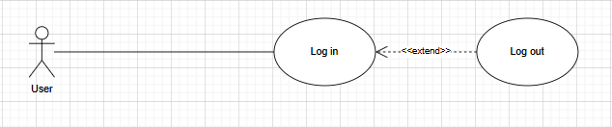

**Purpose:** Ensure **users** information authentication and system security.

**Actors and General Description:**

* **Actors:** User.
* **General Description:** Describes the process of a user logging into the system.

**Main Event Flow:**

|  |  |
| --- | --- |
| Actor's Action | System Response |
| 1. The user selects the login option..  -  3. User enters login information..  4. User submits login information.  -  - | -  2. The login form is displayed.  -  -  5. System authenticates the account. If correct, login is granted; otherwise, it is denied.  6. End of Use Case. |

**Alternative Flow:** If the user enters incorrect information, the system requests a re-entry.

**Specific Requirements:** Username and password must match the registered information.

**Precondition:** The user already has an account.

**Postcondition:** If login is successful, redirect to the homepage.

**2.4.2.5. (User) View detailed air quality data usecase:**

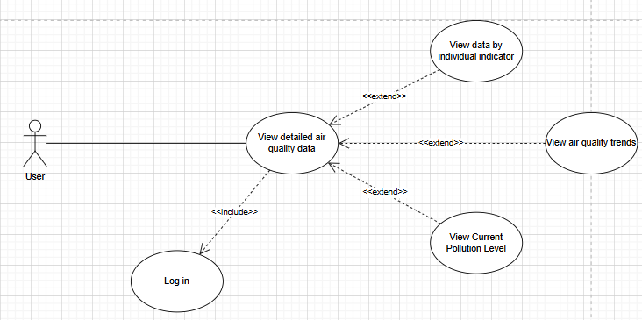

**Purpose:** Allow **users** to view detailed information of an air quality data post.

**Actors and General Description:**

* **Actors:** User.
* **General Description:** Describes the process of a registered user accessing detailed air quality information.

**Main Event Flow:**

|  |  |
| --- | --- |
| Actor's Action | System Response |
| 1. User selects a data post.  -  -  3. User selects “**View Details**”  -  - | -  2. Displays summary of the selected data post.  -  4. Displays full, detailed air quality information  5. Ends the use case. |

**Alternative Flow:** None.

**Specific Requirements:** User must be logged in.

**Preconditions:** User account exists and is authenticated.

**Postconditions:** Detailed data is successfully displayed.

**2.4.2.6. (User) View air quality forecast usecase:**

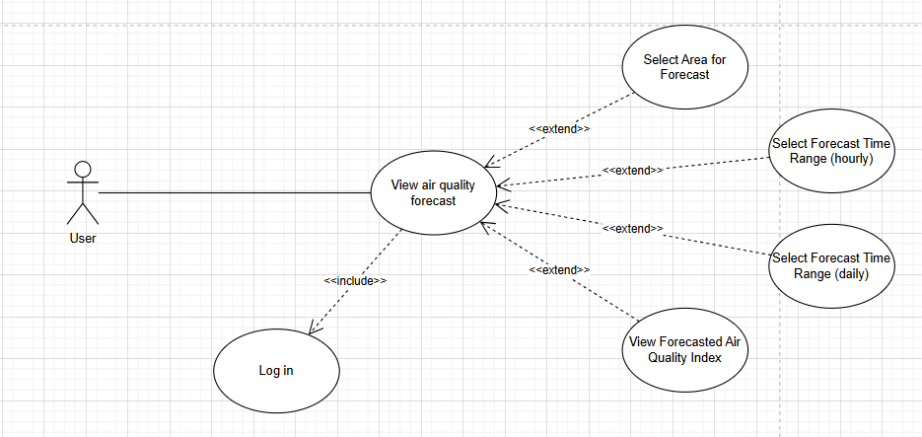

**Purpose:** Allow **users** to view upcoming air quality forecasts for a specific location.

**Actors and General Description:**

* **Actors:** User.
* **General Description:** Describes the process of a registered user viewing predicted air quality data based on time and location.

**Main Event Flow:**

|  |  |
| --- | --- |
| Actor's Action | System Response |
| 1. User selects “**Air Quality Forecast**”.  -  3. User inputs location and timeframe.  -  - | -  2. Displays a form to choose location and timeframe.  -  4. Displays forecasted air quality data.  5. Ends the use case. |

**Alternative Flow:** If no forecast data is available for the selected location or time, the system displays a “No data available” message.

**Specific Requirements:** User must be logged in.

**Preconditions:** Valid user session and internet connection.

**Postconditions:** Forecast data is successfully shown or system notifies if unavailable.

**2.4.2.7. (User) Configure and receive alerts usecase:**

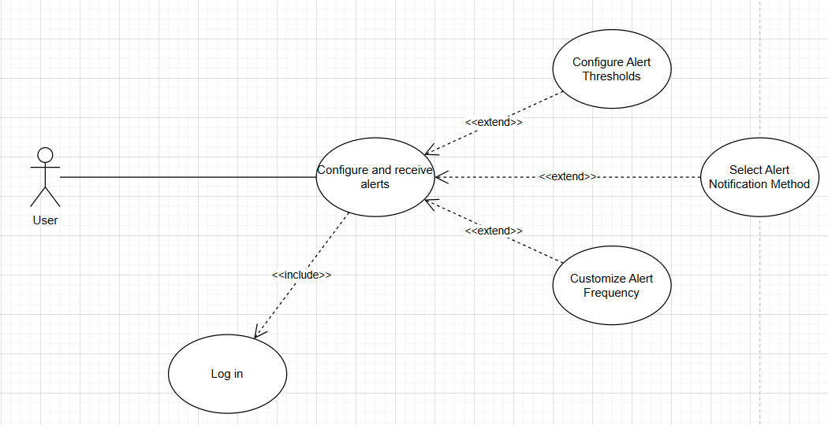

**Purpose:** Enable **users** to configure notification preferences and receive alerts based on specific air quality conditions.

**Actors and General Description:**

* **Actors:** User.
* **General Description:** Describes how a registered user sets alert criteria (e.g., location, pollutant type, threshold), and how the system sends real-time notifications when conditions match.

**Main Event Flow:**

|  |  |
| --- | --- |
| Actor's Action | System Response |
| 1. User navigates to “**Alert Settings**.”  -  3. User sets preferences (e.g., PM2.5 > 100).  5. System monitors data in real-time.  - | -  2. Displays alert configuration form.  -  4. Saves settings and confirms success.  5. If conditions match, sends alert via email or app.  6. Ends the use case. |

**Alternative Flow:** If user inputs invalid criteria, the system prompts for correction.

**Specific Requirements:**.

* Must be logged in.
* Must allow notifications from the app/system.

**Preconditions:** User has a registered account and access to alert settings.

**Postconditions:** Alerts are activated and delivered when conditions are met.

**2.4.2.8. (User) Track data history usecase:**

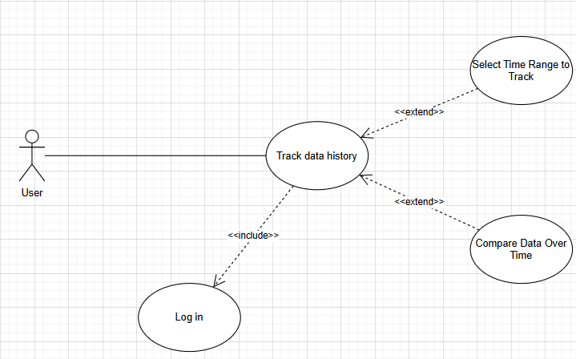

**Purpose:** Enable **users** to configure notification preferences and receive alerts based on specific air quality conditions.

**Actors and General Description:**

* **Actors:** User.
* **General Description:** Describes how a registered user sets alert criteria (e.g., location, pollutant type, threshold), and how the system sends real-time notifications when conditions match.

**Main Event Flow:**

|  |  |
| --- | --- |
| Actor's Action | System Response |
| 1. User navigates to “**Alert Settings**.”  -  3. User sets preferences (e.g., PM2.5 > 100).  5. System monitors data in real-time.  - | -  2. Displays alert configuration form.  -  4. Saves settings and confirms success.  5. If conditions match, sends alert via email or app.  6. Ends the use case. |

**Alternative Flow:** If user inputs invalid criteria, the system prompts for correction.

**Specific Requirements:**.

* Must be logged in.
* Must allow notifications from the app/system.

**Preconditions:** User has a registered account and access to alert settings.

**Postconditions:** Alerts are activated and delivered when conditions are met.

**2.4.2.9. (User) Contact support usecase:**

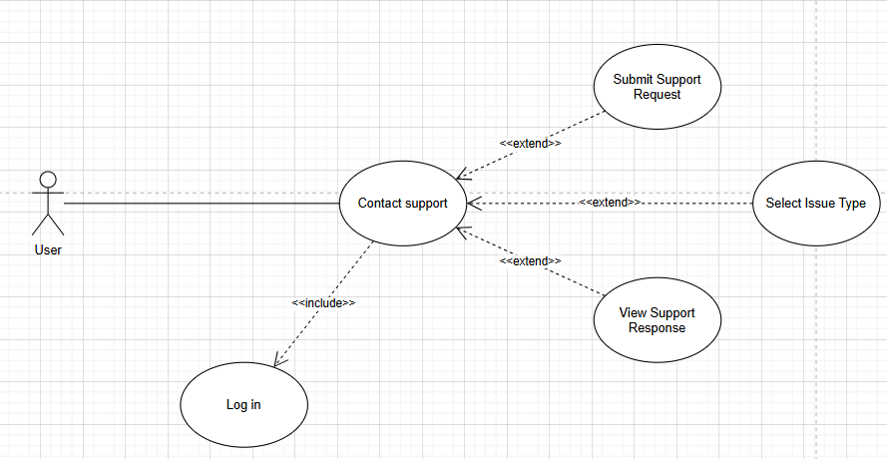

**Purpose:** Allow **users** to request assistance or report issues to the support team.

**Actors and General Description:**

* **Actors:** User.
* **General Description:** Describes the process of a registered user contacting the system’s support team via a form or message.

**Main Event Flow:**

|  |  |
| --- | --- |
| Actor's Action | System Response |
| 1. User selects “**Contact Support.”**  -  3. User enters issue/message details.  4. User submits the support request.  -  - | -  2. Displays the contact support form.  -  -  5. Confirms receipt and notifies support team.  6. Ends the use case. |

**Alternative Flow:** If the message is incomplete or invalid, system requests corrections.

**Specific Requirements:** Input must include a message or description of the issue.

**Preconditions:** User is logged in to access the support feature.

**Postconditions:** Support request is successfully logged for follow-up.

**2.4.2.10. (User/Admin) Forgot password usecase:**

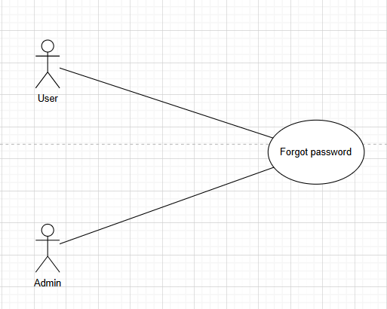

**Purpose:** Allow **users** to recover access to their account when they forget their password.

**Actors and General Description:**

* **Actors:** User, Admin.
* **General Description:** Describes the process of a user initiating a password reset request and the system (or admin) verifying and facilitating the password recovery.

**Main Event Flow:**

|  |  |
| --- | --- |
| Actor's Action | System Response |
| 1. User selects "**Forgot Password**."  -  3. User enters registered email/username.  4. User submits the recovery request.  -  6. User follows the link and sets a new password  - | -  2. Displays password recovery form.  -  -  5. Verifies user identity and sends reset instructions.  -  7. Confirms password change and ends the use case. |

**Alternative Flow:** If system verification fails, the request is denied or forwarded to Admin for manual assistance.

**Specific Requirements:**

* Registered email or username must be correct.
* Reset link expires after a defined time..

**Preconditions:** User must have an existing account.

**Postconditions:** User’s password is updated and access is restored.

**2.4.2.11. (Admin) Log in usecase:**

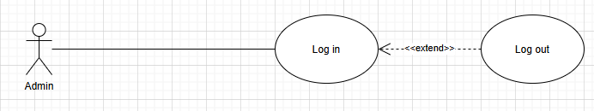

**Purpose:** Ensure **admin** authentication and secure system access.

**Actors and General Description:**

* **Actors:** Admin.
* **General Description:** Describes the process of an admin logging into the system using their credentials.

**Main Event Flow:**

|  |  |
| --- | --- |
| Actor's Action | System Response |
| 1. Admin selects "**Log in."**  -  3. Admin enters credentials (username & password).  4. Admin submits the login request.  -  -  - | -  2. Displays the login form.  -  -  5. Authenticates credentials; grants access if correct.  6. Redirects to admin dashboard.  7. Ends the use case. |

**Alternative Flow:** If credentials are incorrect, the system displays an error message and prompts for re-entry.

**Specific Requirements:**

* Admin credentials must match the registered records.
* System should lock account after multiple failed attempts (if configured).

**Precondition:** Admin account must already exist in the system.

**Postcondition:** Admin gains access to administrative functionalities.

**2.4.2.12. (Admin) Manage sensor data usecase:**

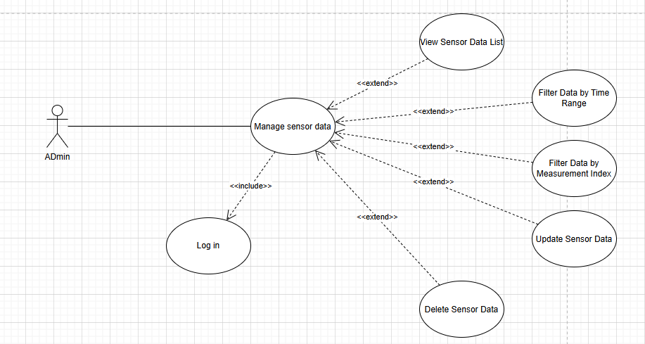

**Purpose:** Allow the **admin** to manage air quality sensor data for accuracy, maintenance, or system updates.

**Actors and General Description:**

* **Actors:** Admin.
* **General Description:**Describes the process by which the admin views, edits, deletes, or updates sensor data within the system.

**Main Event Flow:**

|  |  |
| --- | --- |
| Actor's Action | System Response |
| 1. Admin logs in and navigates to sensor data managent.  -  3. Admin selects a data entry to modify.  4. Admin edits or deletes the data.  -  6. Admin repeats or exits the session  - | -  2. Displays the login form.  -  -  5. Saves changes and confirms successful operation.  -  7. Ends the use case. |

**Alternative Flow:** If the selected data entry is invalid or restricted, the system notifies the admin and cancels the action.

**Specific Requirements:**

* Only admin can access and modify sensor data.
* All changes are logged for auditing.

**Precondition:** Admin must be authenticated and authorized.

**Postcondition:** Sensor data is updated or deleted as per the admin’s input.

**2.4.2.13. (Admin) Set alert thresholds usecase:**

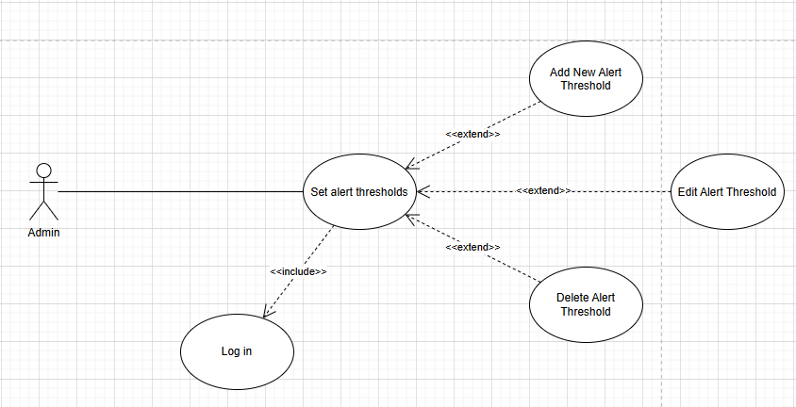

**Purpose:** Allow the **admin** to define or update threshold levels that trigger alerts when air quality data exceeds safe limits.

**Actors and General Description:**

* **Actors:** Admin.
* **General Description:** Describes the process of setting air quality parameter thresholds to activate notifications or system responses when exceeded.

**Main Event Flow:**

|  |  |
| --- | --- |
| Actor's Action | System Response |
| 1. Admin accesses the alert setting section.  -  3. Admin updates or defines new threshold values.  4. Admin submits the updated thresholds.  -  - | -  2. Displays current thresholds and editable.  -  -  5. System saves and applies the new threshold settings.  6. Ends the use case. |

**Alternative Flow:** If the threshold values are outside acceptable limits or incorrectly formatted, the system prompts for correction.

**Specific Requirements:**

* Only admins have permission to configure threshold settings.
* Change should be validated before saving.

**Precondition:** Admin must be logged in with proper privileges.

**Postcondition:** System uses the new threshold values to trigger future alerts.

**2.4.2.14. (Admin) Manage user accounts usecase:**

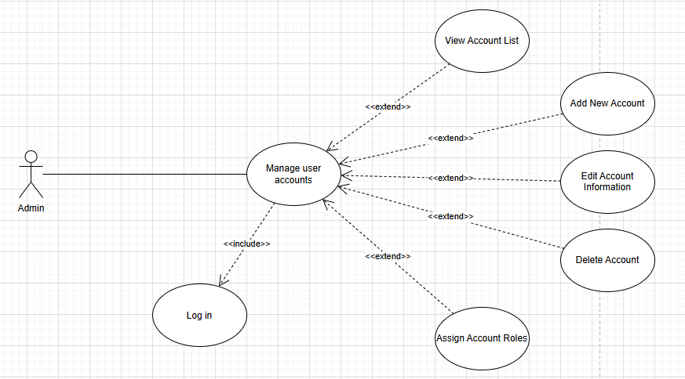

**Purpose:** Allow the **admin** to create, edit, and remove user accounts to maintain system access control.

**Actors and General Description:**

* **Actors:** Admin.
* **General Description:** Describes the process by which the admin manages registered user accounts. Including creating, updating, and deleting accounts.

**Main Event Flow:**

|  |  |
| --- | --- |
| Actor's Action | System Response |
| 1. Admin accesses the user managent panel.  -  3. Admin selects a user account to edit, delete, or add a new one.  4. Admin performs the chosen action (add/ edit/delete).  -  - | -  2. Displays a list of all registered users.  -  -  5.System updates the user database accordingly.  6. Ends the use case. |

**Alternative Flow:** If provided user data is invalid or missing, the system prompts the admin to revise the input.

**Specific Requirements:**

* Only admins have access to the user management interface.
* Each user account must have a unique email or username.

**Precondition:** Admin must be logged in with proper administrative privileges.

**Postcondition:** User accounts are updated according to the admin’s changes.

**2.4.2.15. (Admin) View air quality reports usecase:**

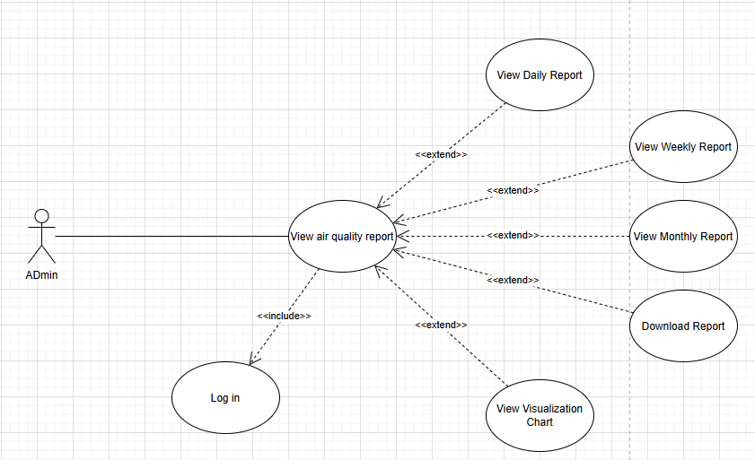

**Purpose:** Allow the **admin** to view comprehensive reports on air quality data collected from **sensors**.

**Actors and General Description:**

* **Actors:** Admin.
* **General Description:** Describes how the admin accesses and reviews detailed air quality reports generated from sensor data over specific timeframes or locationss.

**Main Event Flow:**

|  |  |
| --- | --- |
| Actor's Action | System Response |
| 1. Admin navigates to the report section.  -  3. Admin selects a report criteria (e.g., location, date range).  4. Admin requests to view the report.  -  - | -  2. Displays a list or filter options for report types.  -  -  5. System generates and displays the air quality report.  6. Ends the use case. |

**Alternative Flow:** If no data matches the selected criteria, the system notifies the admin and suggests changing the filters.

**Specific Requirements:**

* Reports may include graphs, averages, anomalies, and downloadable formats.
* Admin can export reports as PDF or CSV.

**Precondition:** Admin must be authenticated and authorized to view reports.

**Postcondition:** The selected air quality report is displayed or downloaded.

**2.4.2.16. (Admin) Statistic air quality report usecase:**

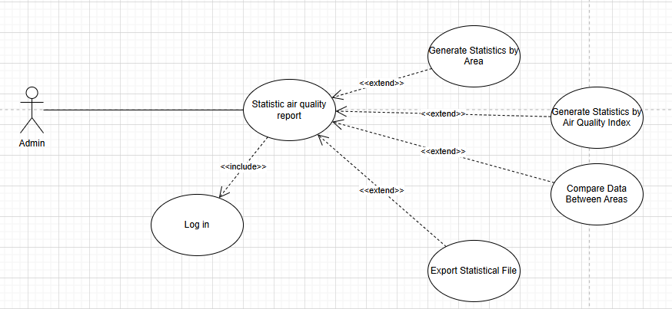

**Purpose:** Enable the **admin** to generate and analyze statistical reports based on collected air quality data.

**Actors and General Description:**

* **Actors:** Admin.
* **General Description:** Describes how the admin selects parameters to generate statistical summaries, trends, and insights from air quality data.

**Main Event Flow:**

|  |  |
| --- | --- |
| Actor's Action | System Response |
| 1. Admin naviagates to the statistics section.  -  3. Admin inputs desired criteria.  4. Admin requests statistical report.  -  - | -  2. Displays options to select location, date range, and metrics.  -  -  5. System processes data and presents statistical visualizations and summaries.  6. Ends the use case. |

**Alternative Flow:** If input criteria result in insufficient data, the system prompts the admin to adjust parameters.

**Specific Requirements:**

* Statistics may include averages, peaks, variance, trends, and comparions over time.
* Graphs and charts are auto-generated.
* Export options available (PDF, Excel).

**Precondition:** Admin must be logged in and have data access privileges.

**Postcondition:** Statistical air quality report is generated and displayed.

**2.4.2.17. (Sensor) Submit air quality data usecase:**

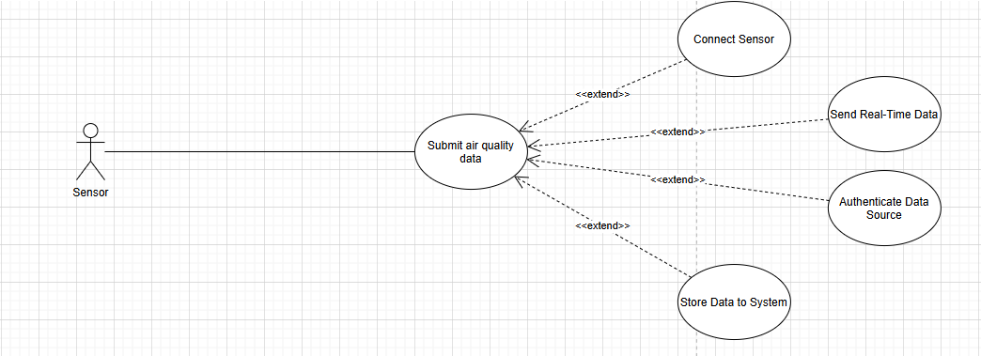

**Purpose:** Allow **IoT sensors** to automatically submit realtime air quality data to the system.

**Actors and General Description:**

* **Actors:** Sensor.
* **General Description:** Describes the automated process of sensors transmitting environmental readings to the backend server for storage and analysis.

**Main Event Flow:**

|  |  |
| --- | --- |
| Actor's Action | System Response |
| 1. Sensor collect air quality data.  2. Sensor transmits data to the system.  -  -  - | -  -  3. System receives and validates the data format and source.  4. System stores the data in the database.  5. Ends the use case. |

**Alternative Flow:** If the data format is invalid or transmission fails, the system logs the error and may request retransmission.

**Specific Requirements:**

* Data must include timestamp, location, and pollutant levels.
* Communication uses secure protocols (e.g., MQTT, HTTPS).

**Precondition:** Sensor is powered on, connected, and properly configred.

**Postcondition:** New air quality data is successfully stored in the system.

**2.5. SEQUENCE DIAGRAM:**

**2.5.1. (Guest) Register Sequence Diagram:**

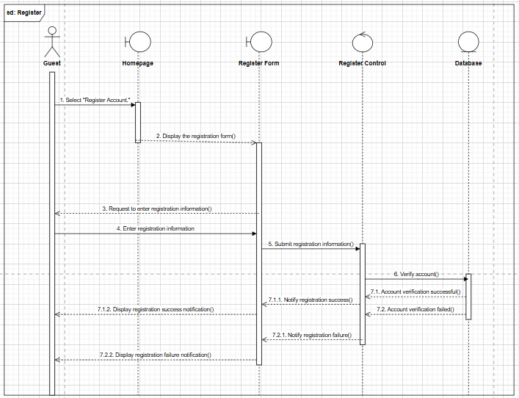

**2.5.2. (Guest) View air quality data Sequence Diagram:**

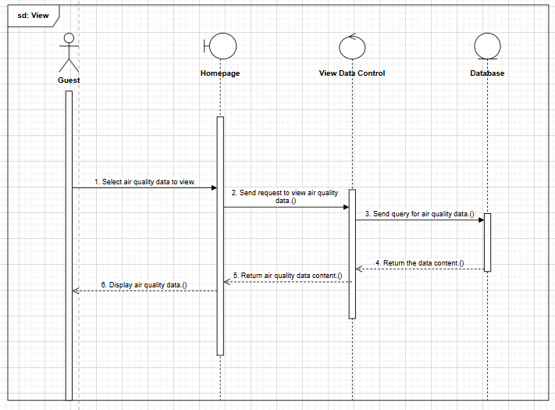

**2.5.3. (Guest) Search information by location Sequence Diagram:**

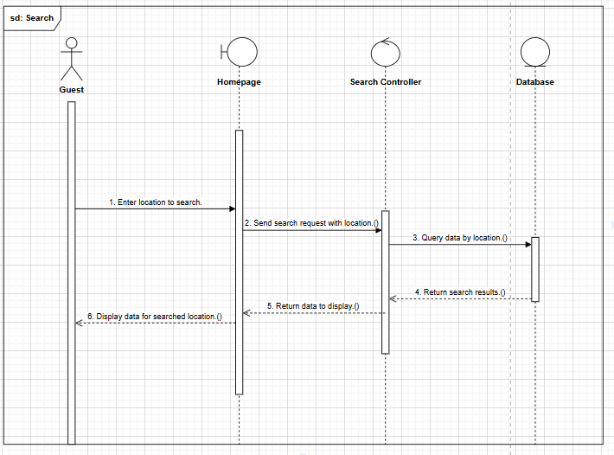

**2.5.4. (User) Log in Sequence Diagram:**

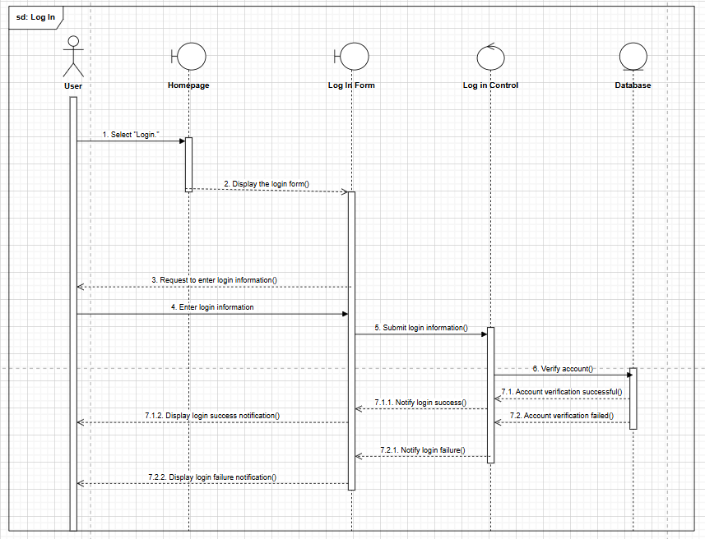

**2.5.5. (User) View detailed air quality data Sequence Diagram:**

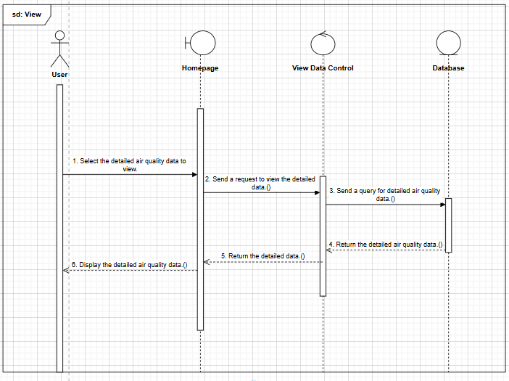

**2.5.6. (User) View air quality forecast Sequence Diagram:**

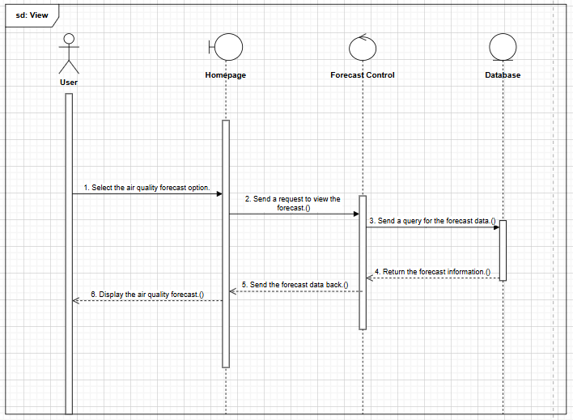

**2.5.7. (User) Configure and receive alert Sequence Diagram:**

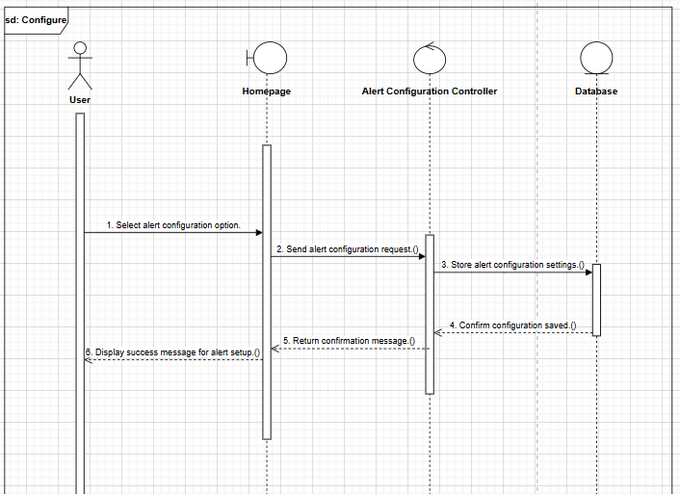

**2.5.8. (User) Track data history Sequence Diagram:**

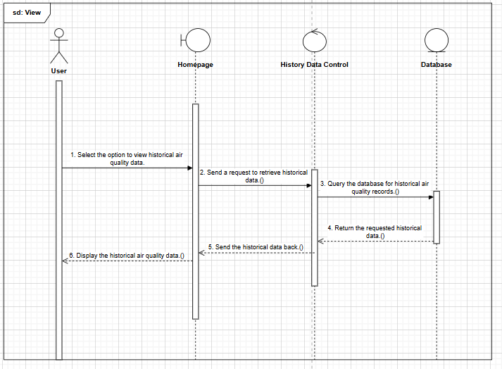

**2.5.9. (User) Contact support Sequence Diagram:**

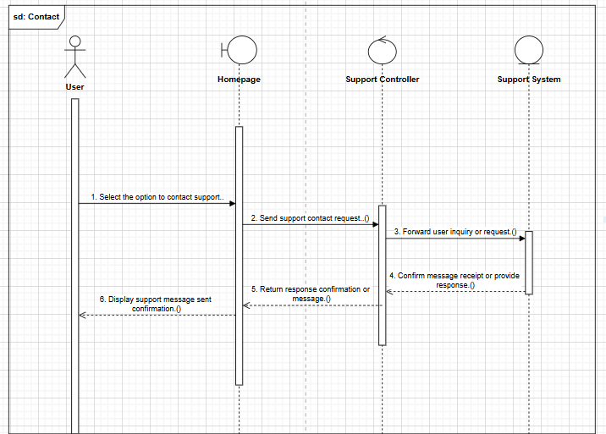

**2.5.10. (User/Admin) Forgot password Sequence Diagram:**

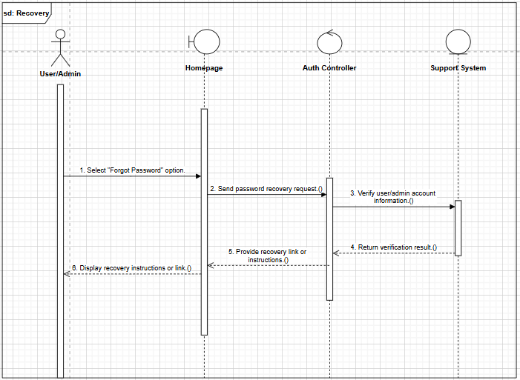

**2.5.11. (Admin) Log in Sequence Diagram:**

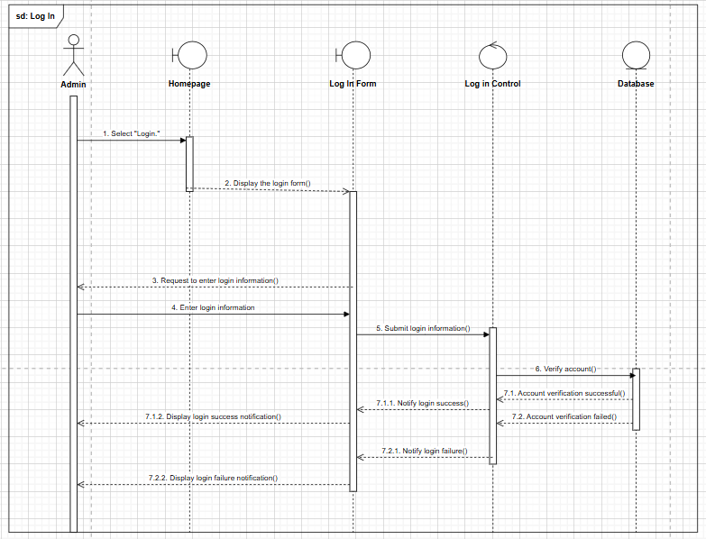

**2.5.12. (Admin) Manage sensor data Sequence Diagram:**

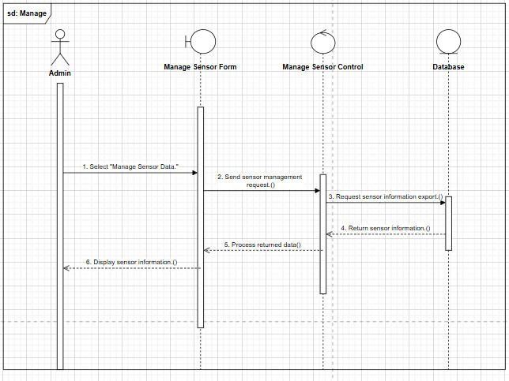

**2.5.13. (Admin) Update Sensor Data Sequence Diagram:**

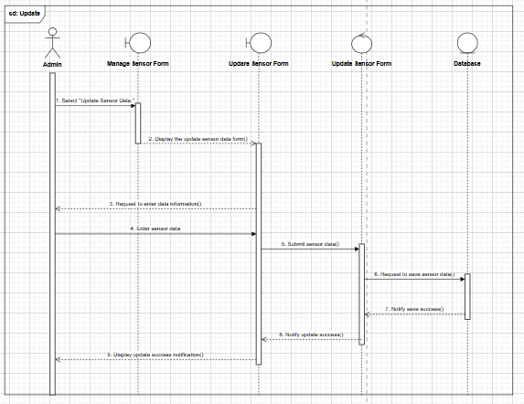

**2.5.14. (Admin) Delete Sensor Data Sequence Diagram:**

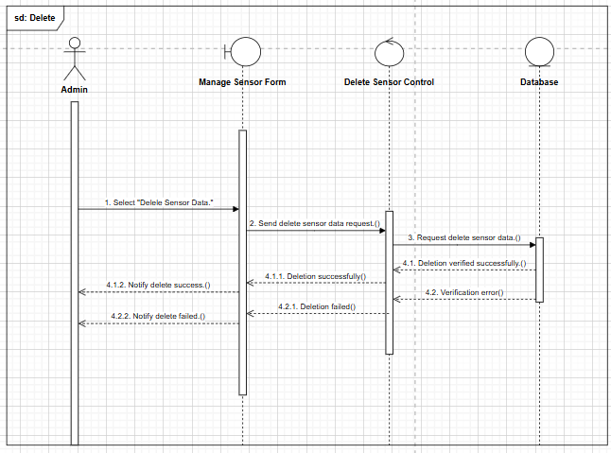

**2.5.15. (Admin) Set alert thresholds Sequence Diagram:**

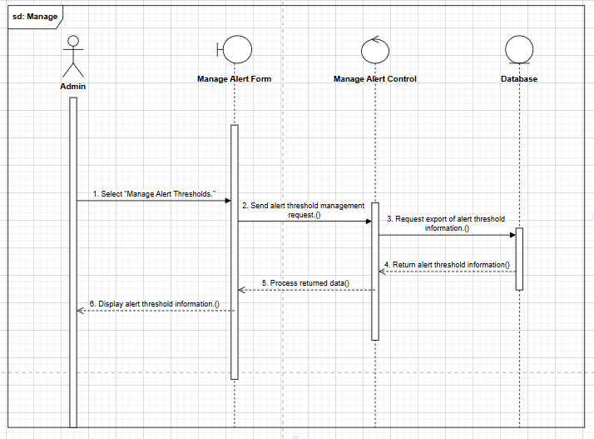

**2.5.16. (Admin) Add New Alert Threshold Sequence Diagram:**

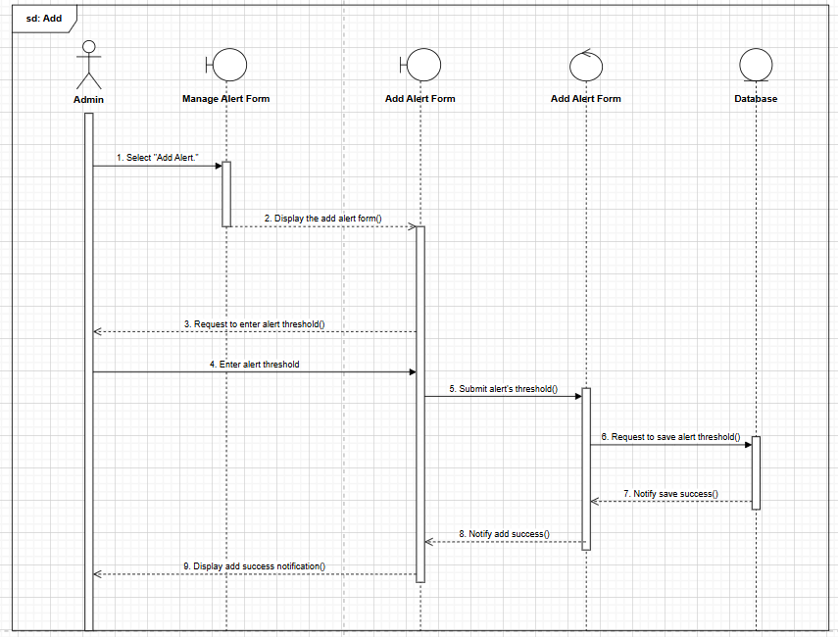

**2.5.17. (Admin) Delete Alert Threshold Sequence Diagram:**

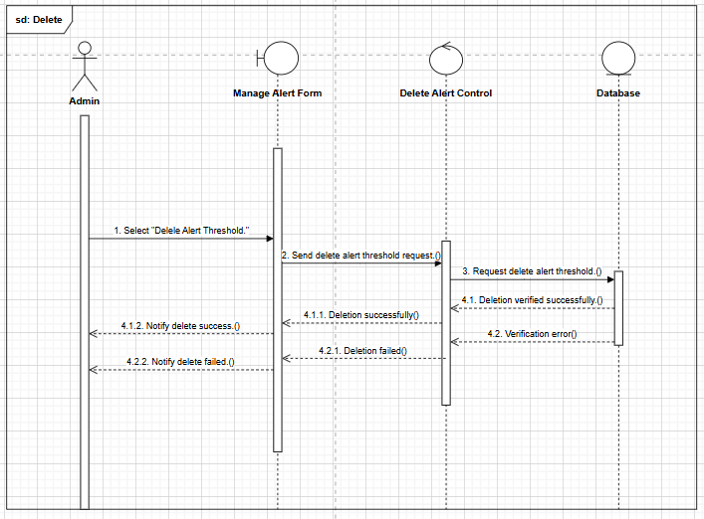

**2.5.18. (Admin) Manage user accounts Sequence Diagram:**

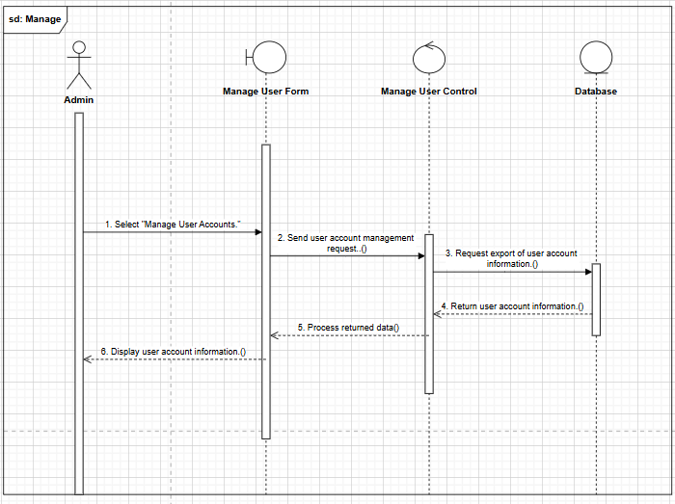

**2.5.19. (Admin) Add New Account Sequence Diagram:**

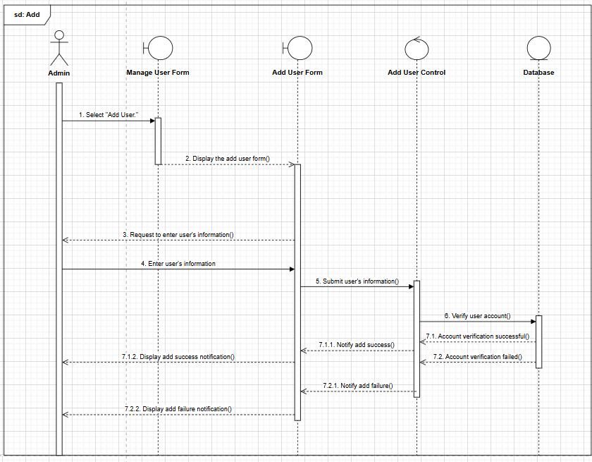

**2.5.20. (Admin) Edit Account Information Sequence Diagram:**

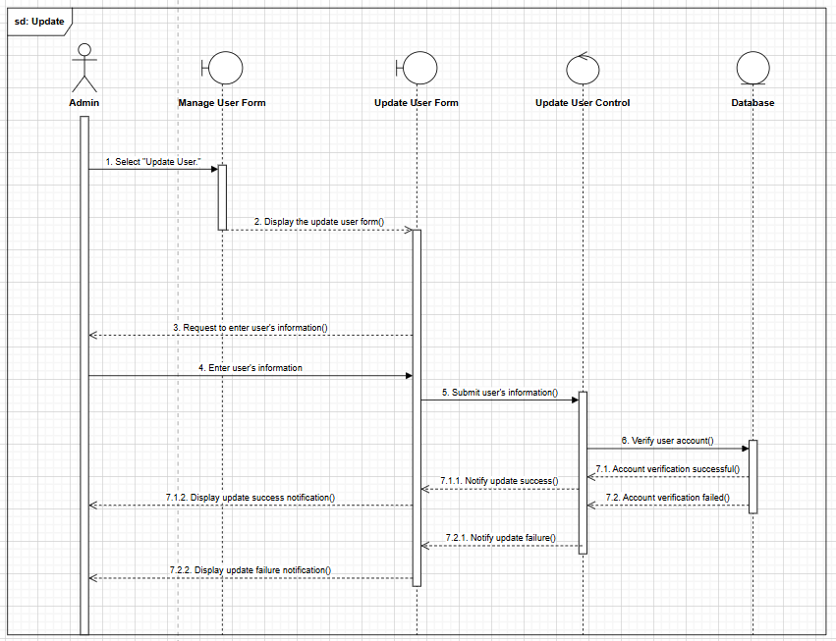

**2.5.21. (Admin) Delete Account Sequence Diagram:**

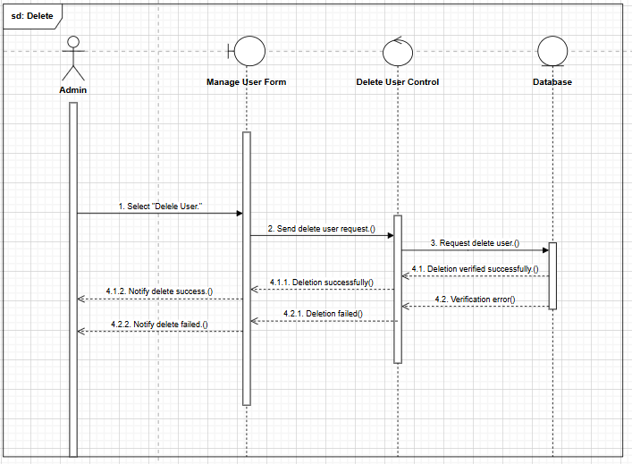

**2.5.22. (Admin) View air quality report Sequence Diagram:**

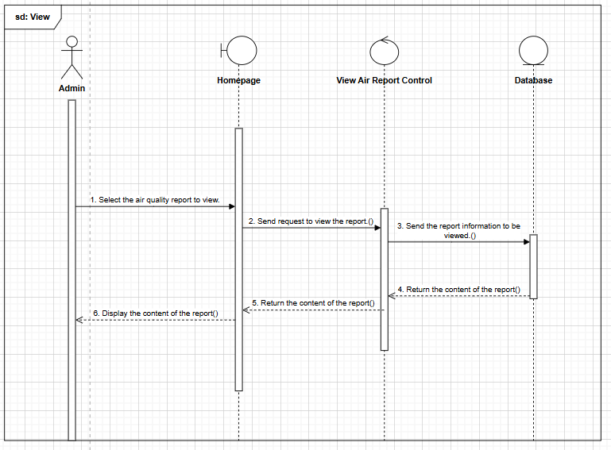

**2.5.23. (Admin) Statistic air quality report Sequence Diagram:**

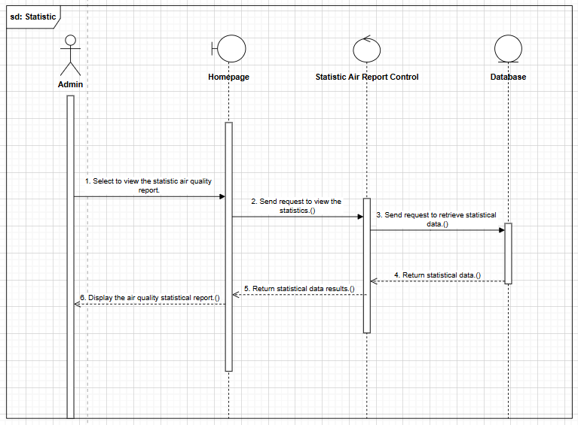

**2.5.24. (Sensor) Submit air quality data Sequence Diagram:**

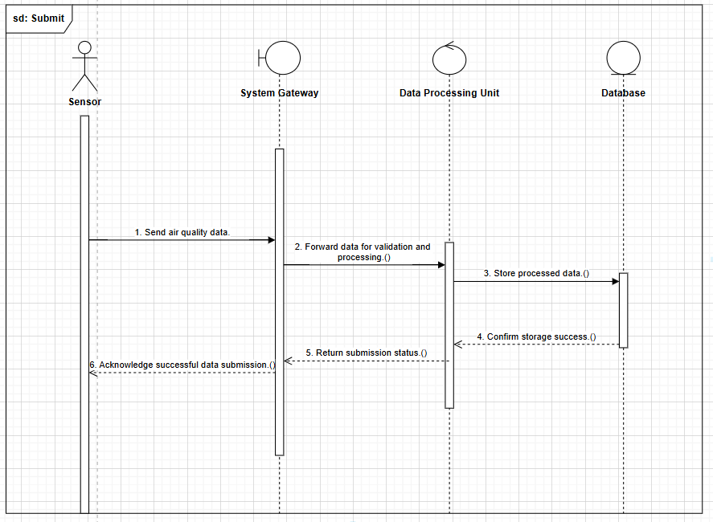

**2.6. ACTIVITY DIAGRAM:**

**2.6.1. (Guest) Register Activity Diagram:**

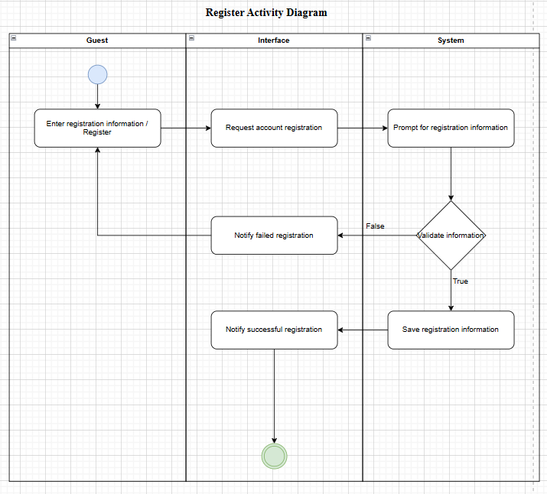

**2.6.2. (Guest) View air quality data Activity Diagram:**

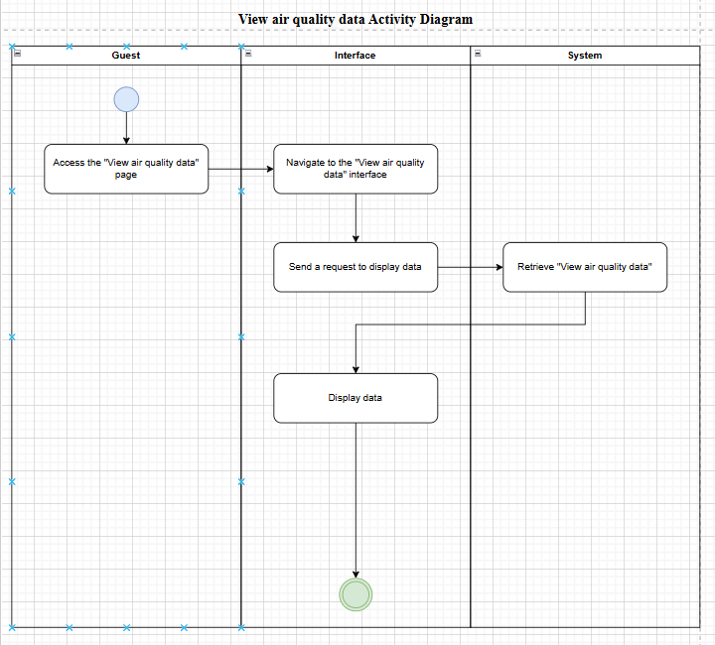

**2.6.3. (Guest) Search information by location Activity Diagram:**

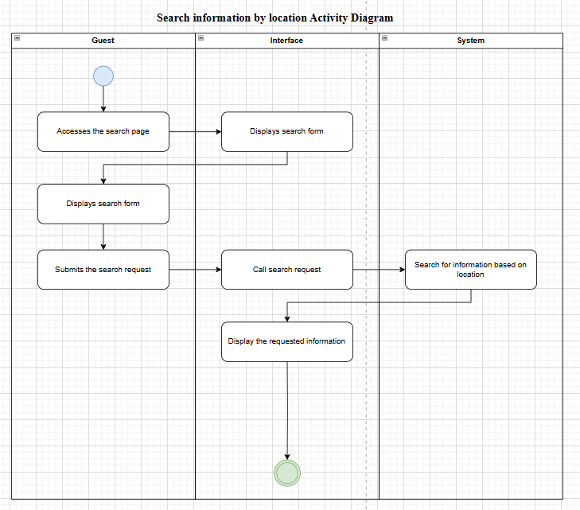

**2.6.4. (User) Log in Activity Diagram:**

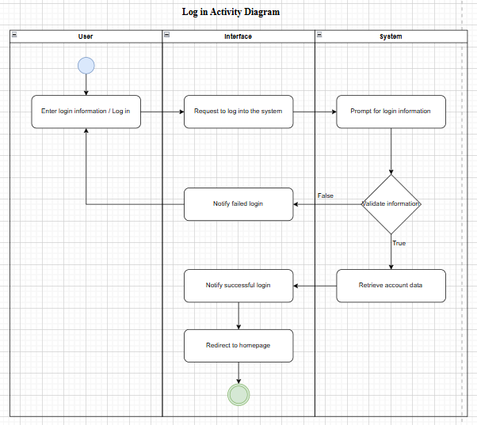

**2.6.5. (User) View detailed air quality data Activity Diagram:**

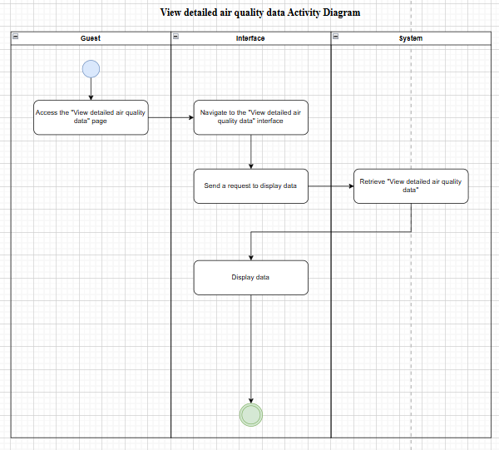

**2.6.6. (User) View air quality forecast Activity Diagram:**

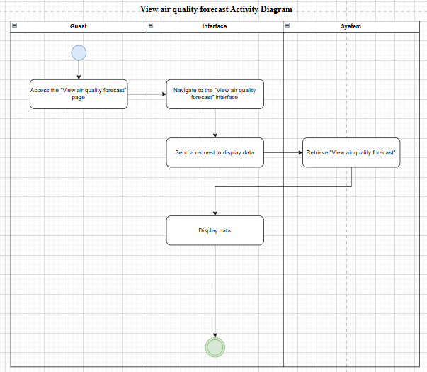

**2.6.7. (User/Admin) Forgot password Activity Diagram:**

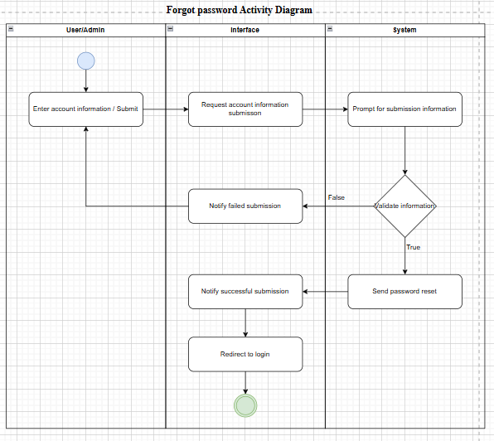

**2.6.8. (Admin) Log in Activity Diagram:**

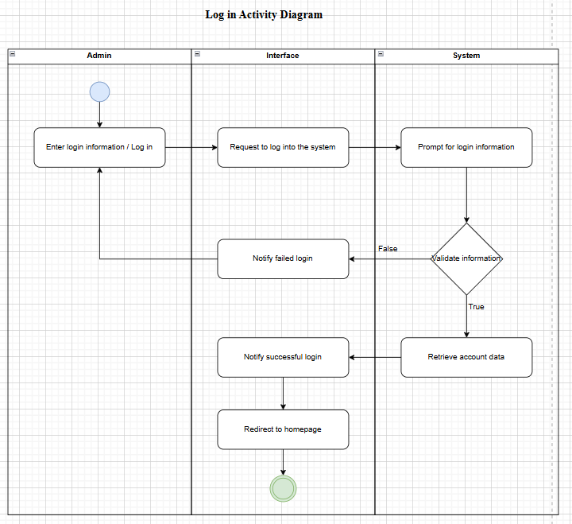

**2.6.9. (Admin) Update Sensor Data Activity Diagram:**

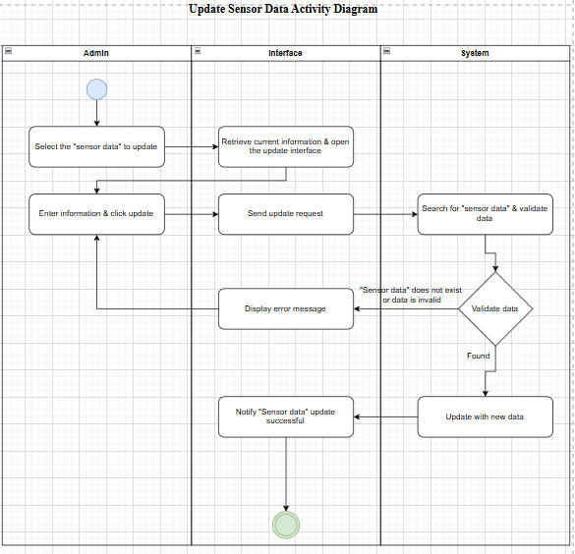

**2.6.10. (Admin) Delete Sensor Data Activity Diagram:**

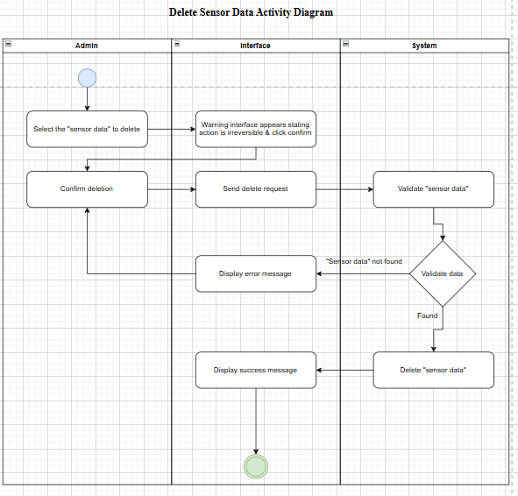

**2.6.11. (Admin) Add New Alert threshold Activity Diagram:**

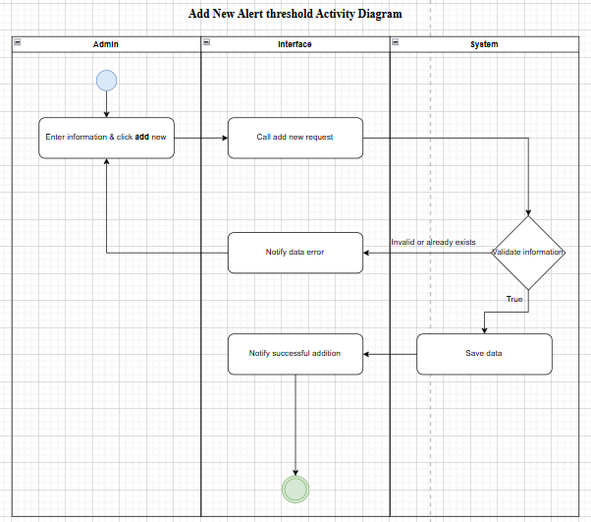

**2.6.12. (Admin) Delete Alert Threshold Activity Diagram:**

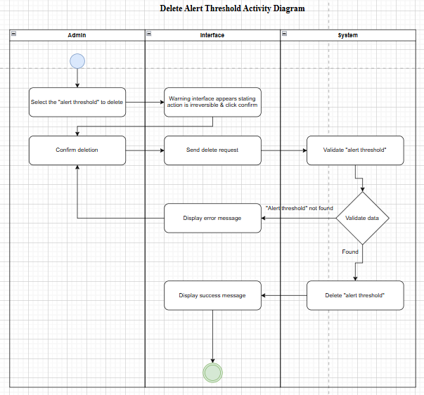

**2.6.13. (Admin) Add New Account Activity Diagram:**

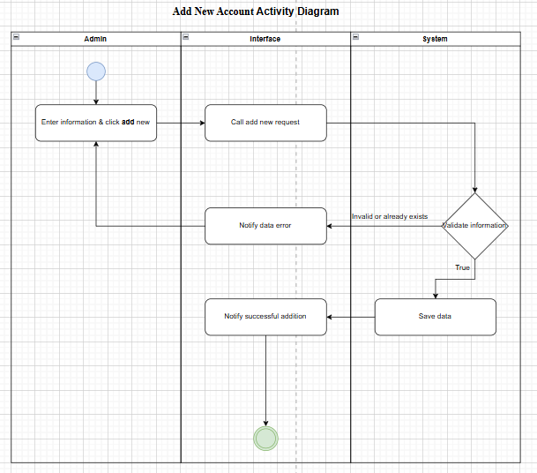

**2.6.14. (Admin) Edit Account Information Activity Diagram:**

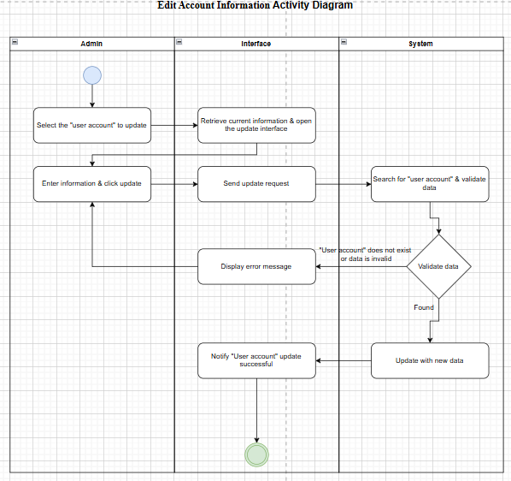

**2.6.15. (Admin) Delete Account Activity Diagram:**

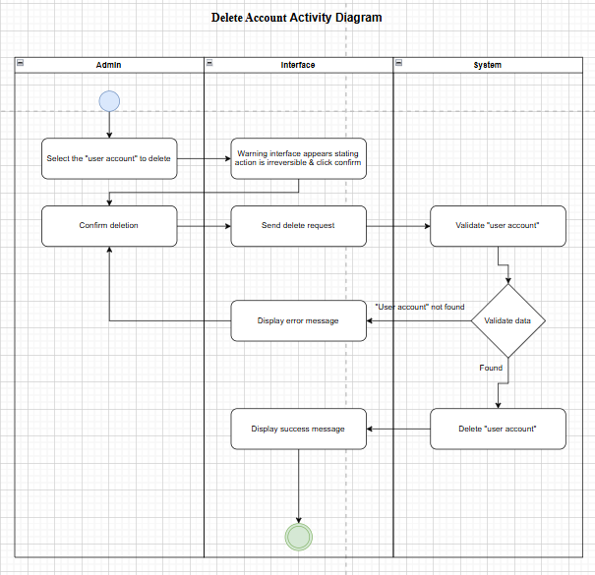

**2.6.16. (Admin) View air quality report Activity Diagram:**

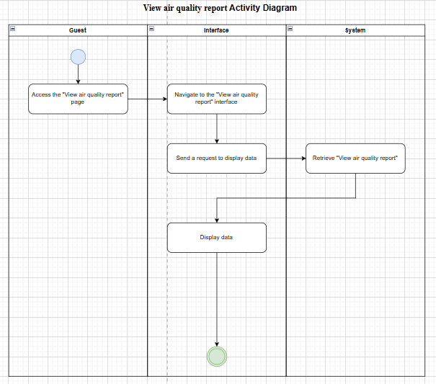

**2.6.17. (Admin) Statistic air quality report Activity Diagram:**

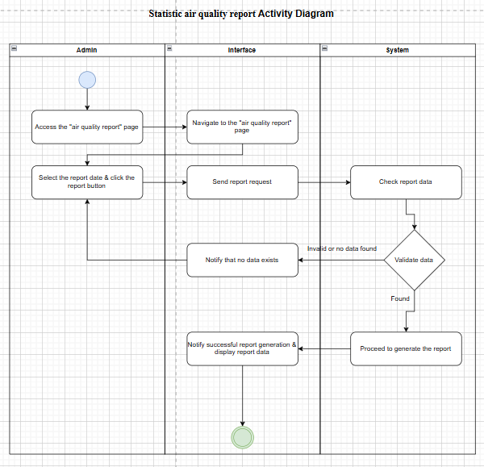

**2.7. CLASS DIAGRAM:**

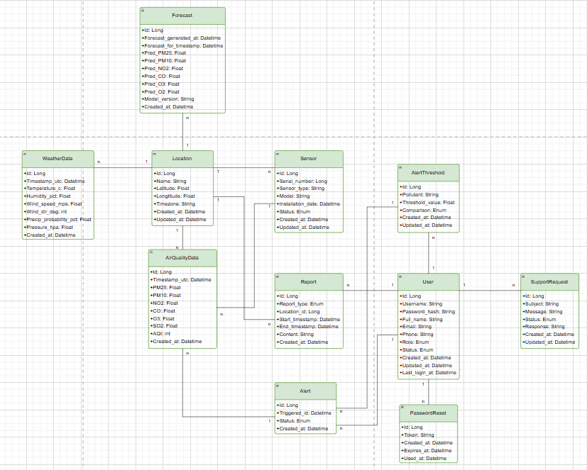**2.7.2. Database Relationship Diagram (DRD):**

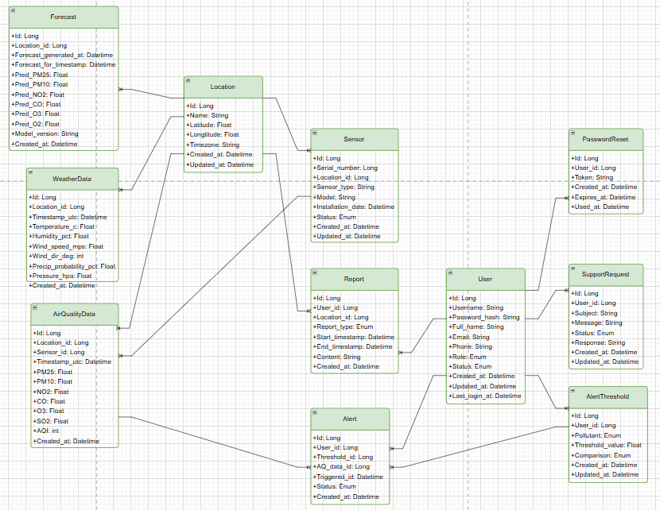

**2.8. DATABASE DESIGN:**

**2.8.1. Enhanced entity-relationship Model (EER):**

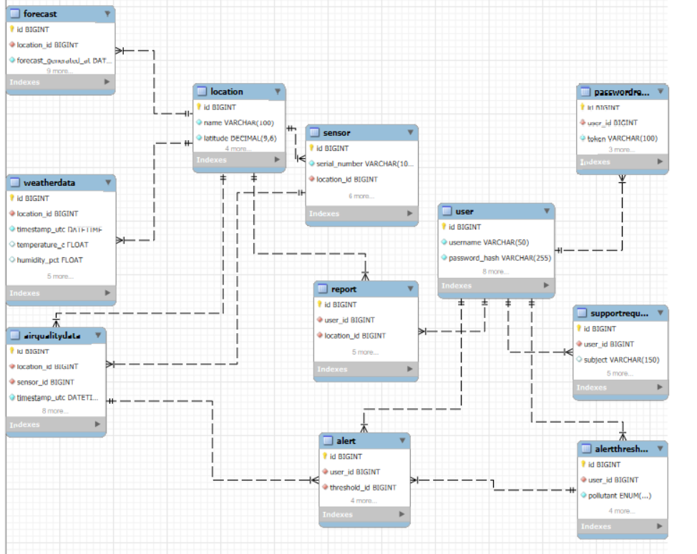

**2.8.2. Physical Model:**

* **Location**

|  |  |  |  |  |
| --- | --- | --- | --- | --- |
| **Column** | **Type** | **Null** | **Extra** | **Link to** |
| **id** | **bigint** | **No** | **auto_increment** |  |
| name | varchar(100) | No |  |  |
| latitude | decimal(9,6) | No |  |  |
| longtitude | decimal(9,6) | No |  |  |
| timezone | varchar(50) | No |  |  |
| created_at | datetime | No | default current_timestamp |  |
| update_at | datetime | No | default current_timestamp on update current_timestamp |  |

* **Sensor**

|  |  |  |  |  |
| --- | --- | --- | --- | --- |
| **Column** | **Type** | **Null** | **Extra** | **Link to** |
| **id** | **bigint** | **No** | **auto_increment** |  |
| serial_number | varchar(100) | No | unique |  |
| location_id | bigint | Yes |  | location.id |
| sensor_type | varchar(50) | No |  |  |
| model | varchar(100) | Yes |  |  |
| installation_date | date | Yes |  |  |
| status | enum | No | default active |  |
| created_at | datetime | No | default current_timestamp |  |
| updated_at | datetime | No | default current_timestamp on update current_timestamp |  |

* **AirQualityData**

|  |  |  |  |  |
| --- | --- | --- | --- | --- |
| **Column** | **Type** | **Null** | **Extra** | **Link to** |
| **id** | **bigint** | **No** | **auto_increment** |  |
| location_id | bigint | No |  | location.id |
| sensor_id | bigint | No |  | sensor.id |
| timestamp_utc | datetime | No |  |  |
| pm2.5 | float | Yes |  |  |
| pm10 | float | Yes |  |  |
| no2 | float | Yes |  |  |
| co | float | Yes |  |  |
| o3 | float | Yes |  |  |
| so2 | float | Yes |  |  |
| aqi | int | Yes |  |  |
| created_at | datetime | No | default current_timestamp |  |

* **WeatherData**

|  |  |  |  |  |
| --- | --- | --- | --- | --- |
| **Column** | **Type** | **Null** | **Extra** | **Link to** |
| **id** | **bigint** | **No** | **auto_increment** |  |
| location_id | bigint | No |  | location.id |
| timestamp_utc | datetime | No |  |  |
| temperature_c | float | Yes |  |  |
| humidity_pct | float | Yes |  |  |
| wind_speed_mps | float | Yes |  |  |
| wind_dir_deg | int | Yes |  |  |
| precip_probability_pct | float | Yes |  |  |
| pressure_hpa | float | Yes |  |  |
| created_at | datetime | No | default current_timestamp |  |

* **Forecast**

|  |  |  |  |  |
| --- | --- | --- | --- | --- |
| **Column** | **Type** | **Null** | **Extra** | **Link to** |
| **id** | **bigint** | **No** | **auto_increment** |  |
| location_id | bigint | No |  | location.id |
| forecast_generated_at | datetime | No |  |  |
| forecast_at_timestamp | datetime | No |  |  |
| pred_pm25 | float | Yes |  |  |
| pred_pm10 | float | Yes |  |  |
| pred_no2 | float | Yes |  |  |
| pred_co | float | Yes |  |  |
| pred_o3 | float | Yes |  |  |
| pred_so2 | float | Yes |  |  |
| model_version | varchar(50) | Yes |  |  |
| created_at | datetime | No | default current_timestamp |  |

* **User**

|  |  |  |  |  |
| --- | --- | --- | --- | --- |
| **Column** | **Type** | **Null** | **Extra** | **Link to** |
| **id** | **bigint** | **No** | **auto_increment** |  |
| username | varchar(50) | No | unique |  |
| password_hash | varchar(255) | No |  |  |
| full_name | varchar(100) | Yes |  |  |
| email | varchar(100) | No | unique |  |
| phone | varchar(20) | Yes |  |  |
| role | enum | No | default ‘user’ |  |
| status | enum | No | default ‘active’ |  |
| created_at | datetime | No | default current_timestamp |  |
| updated_at | datetime | No | default current_timestamp on update current_timestamp |  |
| last_login_at | datetime | Yes |  |  |

* **AlertThreshold**

|  |  |  |  |  |
| --- | --- | --- | --- | --- |
| **Column** | **Type** | **Null** | **Extra** | **Link to** |
| **id** | **bigint** | **No** | **auto_increment** |  |
| user_id | bigint | No |  | user.id |
| pollutant | enum | No |  |  |
| threshold_value | float | No |  |  |
| comparison | enum | No |  |  |
| created_at | datetime | No | default current_timestamp |  |
| updated_at | datetime | No | default current_timestamp on update current_timestamp |  |

* **Alert**

|  |  |  |  |  |
| --- | --- | --- | --- | --- |
| **Column** | **Type** | **Null** | **Extra** | **Link to** |
| **id** | **bigint** | **No** | **auto_increment** |  |
| user_id | bigint | No |  | user.id |
| threshold_id | bigint | No |  | threshold.id |
| aq_data_id | bigint | No |  | aq_data.id |
| triggered_at | datetime | No |  |  |
| status | enum | No | default ‘sent’ |  |
| created_at | datetime | No | default current_timestamp |  |

* **Report**

|  |  |  |  |  |
| --- | --- | --- | --- | --- |
| **Column** | **Type** | **Null** | **Extra** | **Link to** |
| **id** | **bigint** | **No** | **auto_increment** |  |
| user_id | bigint | No |  | user.id |
| location_id | bigint | No |  | location.id |
| report_type | enum | No |  |  |
| start_timestamp | datetime | Yes |  |  |
| end_timestamp | datetime | Yes |  |  |
| content | text | Yes |  |  |
| created_at | datetime | No | default current_timestamp |  |

* **SupportRequest**

|  |  |  |  |  |
| --- | --- | --- | --- | --- |
| **Column** | **Type** | **Null** | **Extra** | **Link to** |
| **id** | **bigint** | **No** | **auto_increment** |  |
| user_id | bigint | No |  | user.id |
| subject | varchar(150) | Yes |  |  |
| message | text | No |  |  |
| status | enum | No | default ‘open’ |  |
| response | text | Yes |  |  |
| created_at | datetime | No | default current_timestamp |  |
| updated_at | datetime | No | default current_timestamp on update current_timestamp |  |

* **PasswordReset**

|  |  |  |  |  |
| --- | --- | --- | --- | --- |
| **Column** | **Type** | **Null** | **Extra** | **Link to** |
| **id** | **bigint** | **No** | **auto_increment** |  |
| user_id | bigint | No |  | user.id |
| token | varchar(100) | No | unique |  |
| created_at | datetime | No | default current_timestamp |  |
| expires_at | datetime | No |  |  |
| used_at | datetime | Yes |  |  |